RW-LED-STR

Wood lamp for fixed workstation 9 LEDs – Elongated shape
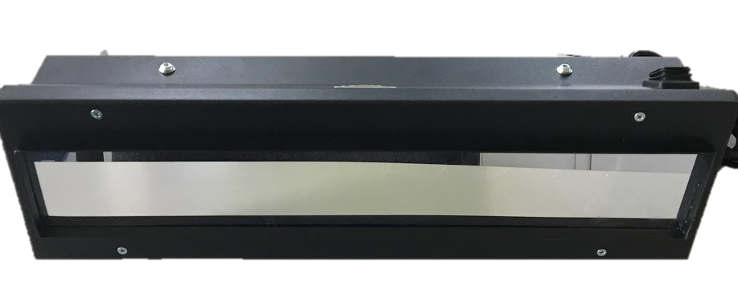
Compared to traditional lamps, they are more compact, quieter and run cooler.

Instant switching on and off.
Low noise and low heating of the work area.

UV lighting by means of 9 high-power LEDs
Peak wavelength: 365 nm
Illuminating power: > 3,500 µW/cm² at 380 mm uniform
Illuminated surface: 800 x 300 mm
Natural light emission in UV mode: <5 lux at 380mm
Power supply: 230V – 50Hz
Dimensions: 520 x 150 x 120 mm
With declaration of conformity EN ISO 3059.

Effective and safe UV filter: only the wavelength spectrum of 320÷380 nm is transmitted, peak at 365 nm.
It is mandatory to use the appropriate PPE (UV protection goggles): a pair is supplied.
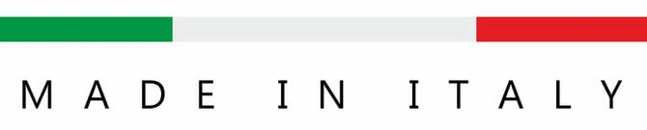

RW-LED-STR-multi

Wood lamp for fixed workstation 9 LEDs – Elongated shape – Selectable intensity
Technical features such as the RW-LED-STR.
The emission power is selectable by a step potentiometer:
- low intensity, for verification of flushing of fluorescent penetrant
- average intensity, for the inspection
- maximum intensity, for the inspection

RW-LED-STR-multi2

Wood lamp for fixed workstation 9 LEDs – Elongated shape – Automatically selectable intensity
Technical features such as the RW-LED-STR.
The emission power can be selected by the touchscreen panel of the system and/or automatically recalled from the control specifications:
- low intensity, for verification of flushing of fluorescent penetrant
- average intensity, for the inspection
- maximum intensity, for the inspection

